Project Report on

AUREATE FOOD DEVILERY

at

Aimdek Technologies Pvt. Ltd.

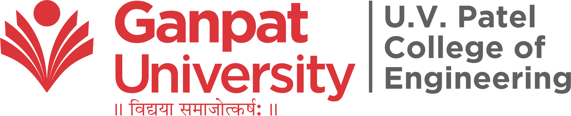

External Guide : | Prepared By:
Mr. Jay Virsodiya | Mr. Aftab Sipahi (19012012005)
Internal Guide :
Prof. Chirag Gami

B.Tech Semester VIII
(Computer Engineering)

May 2022

Submitted to,
Department of Computer Engineering
U.V. Patel College of Engineering
Ganpat University, Kherva - 384 012

U.V. PATEL COLLEGE

OF

ENGINEERING

DD/MM/YY

CERTIFICATE

TO WHOM SO EVER IT MAY CONCERN

This is to certify that Mr. Aftab Sipahi student of B.Tech. Semester VIII (Computer Engineering) has completed his/her full semester on site project work titled “Aureate Food Delivery” satisfactorily in partial fulfillment of the requirement of Bachelor of Technology degree of Computer Engineering of Ganpat University, Kherva, Mehsana in the year 2021-2022.

College Project Guide

Sign Dr. Paresh M. Solanki,
HOD, Computer Engineering
Prof. Chirag Gami

